Contents
Overview of Planned Systems for Assessment 2 2
Weapon System 2
Enemy System 2
Technical Breakdown of Systems for Assessment 2 4
Weapon System 4
Enemy System 4

Planned System

Weapon System
This system will be used by the enemy and player and will be projectile base. The weapon will shoot straight in the direction it is facing.
This system will allow the player to shoot down enemies or anything that would block their way in the world. The weapon will also play a sound that fits what they have destroyed, for example when an enemy dies or when a wall blocking the path is destroyed.
This weapon will most likely look like a shape around the player. Ideally, it will follow the mouse movements moving cylindrically around the player.
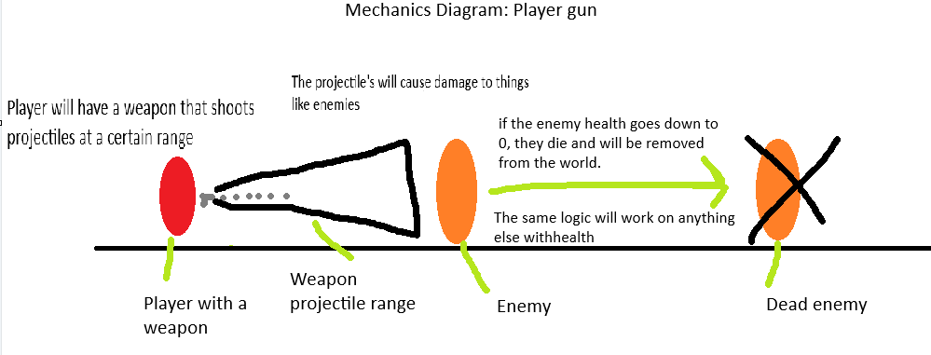

Enemy System
These are enemies that look similar to the player but have a different colour.
The enemies may be static in place or be randomly moving around select bits of the map. The enemies will also have the weapon, so that when they detect the player, they’ll start chasing them and shooting them.

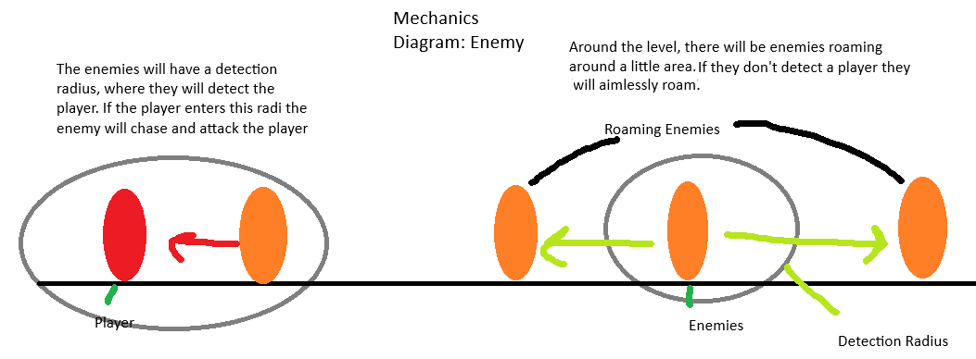

Technical Breakdown of Systems

Weapon System
One thing I will do when making the system, is to keep the scripts separate and appropriate to what they do. This separation keeps the scripts easy to read and expand on in the future.
For this system, I don’t expect to have classes as all this system will do is gather the health of the object it touches and take away from it.
The only exposed value this system will have is how much damage it does. This will be exposed to the editor to make it easier to alter the system if need be.

Enemy System
For this system, I will instead make a single enemy controller. This controller will have the movement controls, the health, damage and detection. The main reason for doing this is that those smaller subsystems are very small, and there wouldn’t be much point in having a separate script for a small system. IF they ever do expand then I will separate them.

